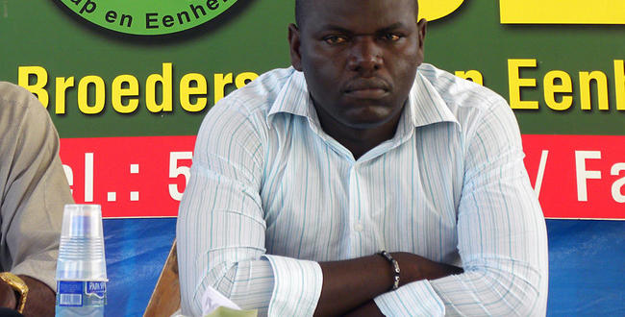
Parliament member: 'Homosexuality has to be erradicated.'

A disease. A deviation that should be erradicated completely," says Ronny Asabina.

Suriname Men United is shocked by these statements.

Asabina made his statement during Amafo's (ABOP) speech. Asabina interrupted Amafo's speech to inquire about President's Bouterse anti-homosexuality regime. “Homosexuality is a disease, a deviation. Recognizing same sex marriages is a European epidemic," says Asabina.
The statements caused a lot of commotion in the Surinamese society. Varios media houses conducted street interviews on Tuesday in Paramaribo, which show that most Surinamese support Asabina's statements. “He is voicing the opinion of the people," quotes the local newspaper, De Ware Tijd

Stab in the back
Suriname Men United said that Asabina's statements are like a stab in the back. This only results in segregation of the Surinamese society, a society of which homosexuals are also a part of." "BEP stands for Brotherhood and Unity. Where is the unity for the homosexual brother? asks Kenneth van Emden, Chairman of Suriname Men United (SMU).
The organization shall write a letter to mister Asabina to let him know his statements were in poor taste. Asabina said that he shall not change his statement or issue an apology. “Homosexuality should be erradicated in Suriname. It never was good and will never be good," says Asabina.
Ruth Wijdenbosch from the National Party Suriname, Vice Chairman of the National Assembly, posted a comment on her Facebook page regarding the controversial statements. "I disagree with anyone who says that homosexuality is a disease. I am against every form of discrimination. Movements against homosexuals shall not be supported by me.
Published on: 13 juli 2011 - 12:52 am | by Pieter Van Maele (Photo: Pieter Van Maele)

